TestNG is a powerful testing framework, an enhanced version of JUnit which was in use for a long time before TestNG came into existence. NG stands for 'Next Generation'.

TestNG framework provides the following features:

* Annotations help us organize the tests easily.
* Flexible test configuration.
* Test cases can be grouped more easily.
* Parallelization of tests can be achieved using TestNG.
* Support for data-driven testing.
* Inbuilt reporting.

**Installing TestNG for Eclipse**

**Step 1**: Launch Eclipse and select 'Install New Software'.

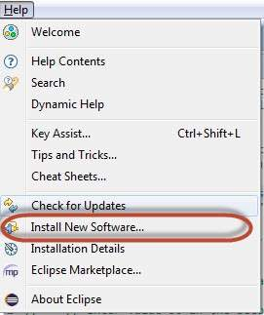

**Step 2** : Enter the URL as 'http://beust.com/eclipse' and click 'Add'.

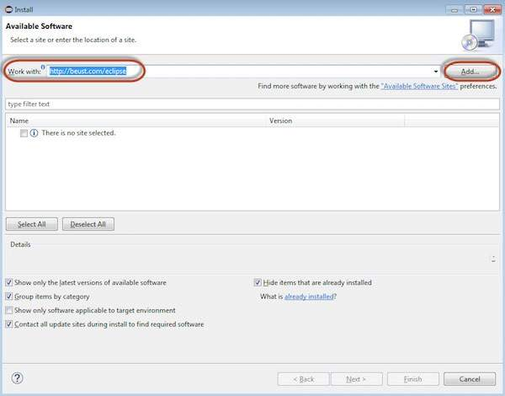

**Step 3**: The dialog box 'Add Repository' opens. Enter the name as 'TestNG' and click 'OK'

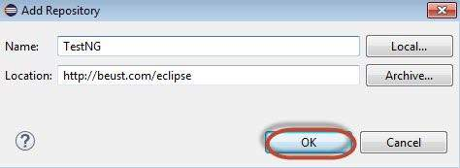

**Step 4**: Click 'Select All' and 'TestNG' would be selected as shown in the figure.

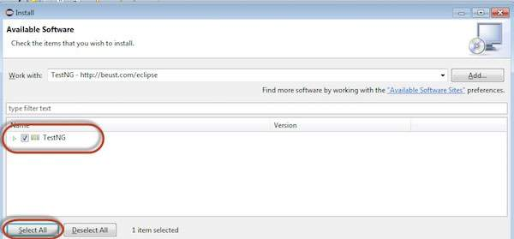

**Step 5**: Click 'Next' to continue.

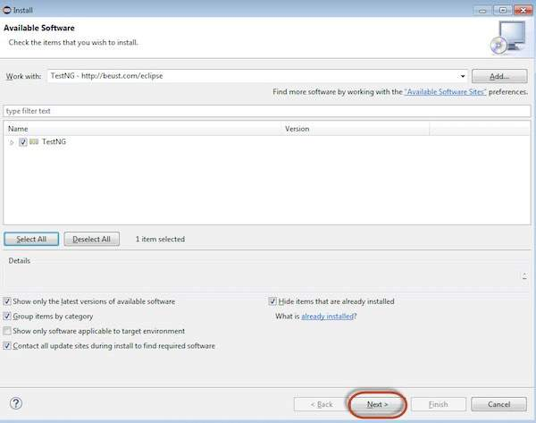

**Step 6**: Review the items that are selected and click 'Next'.

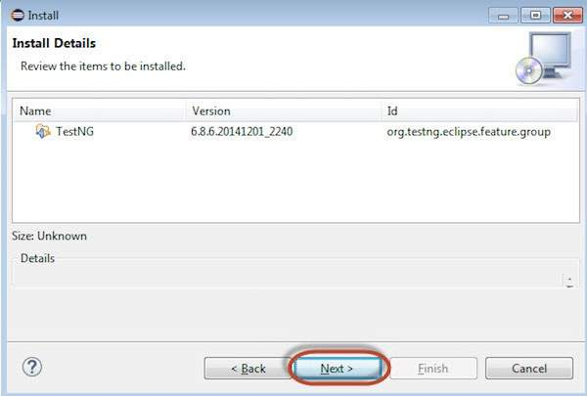

**Step 7**: "Accept the License Agreement" and click 'Finish'.

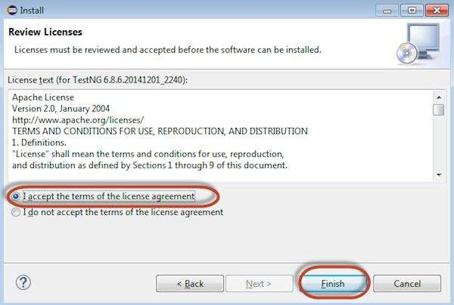

**Step 8**: TestNG starts installing and the progress would be shown follows.

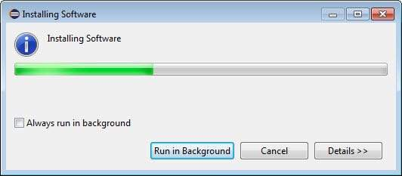

**Step 9**: Security Warning pops up as the validity of the software cannot be established. Click 'Ok'.

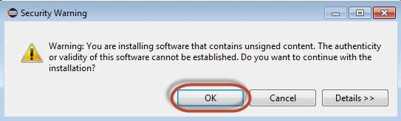

**Step 10**: The Installer prompts to restart Eclipse for the changes to take effect. Click 'Yes'.

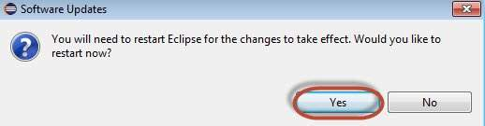

**TestNG-Eclipse Setup**

**Step 1**: Launch Eclipse and create a 'New Java Project' as shown below.

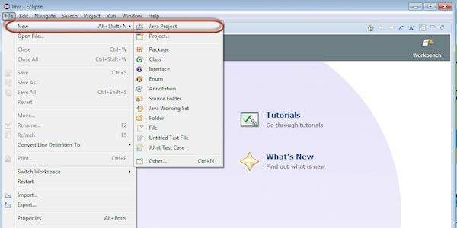

**Step 2**: Enter the project name and click 'Next'.

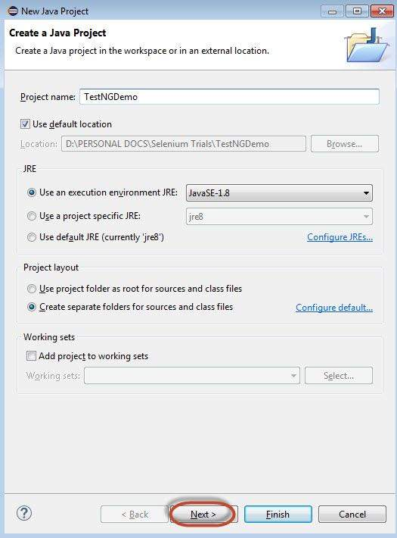

**Step 3**: Navigate to "Libraries" Tab and Add the Selenium Remote Control Server JAR file by clicking on "Add External JAR's" as shown below.

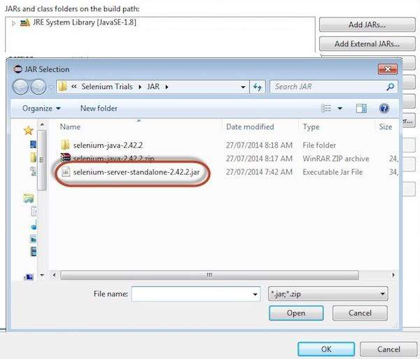

**Step 4**: The added JAR file is shown here. Click 'Add Library'.

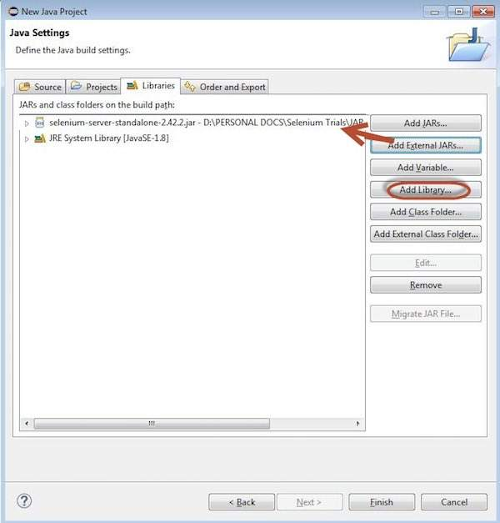

**Step 5**: The 'Add Library' dialog opens. Select 'TestNG' and click 'Next' in the 'Add Library' dialog box.

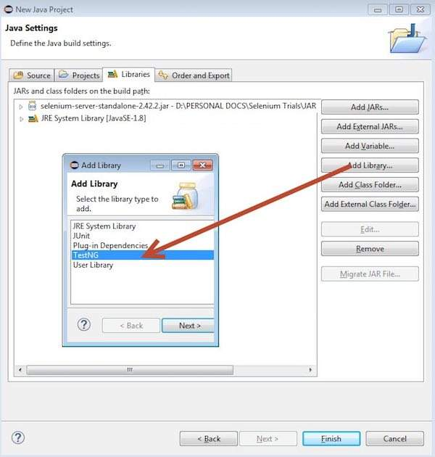

**Step 6**: The added 'TestNG' Library is added and it is displayed as shown below.

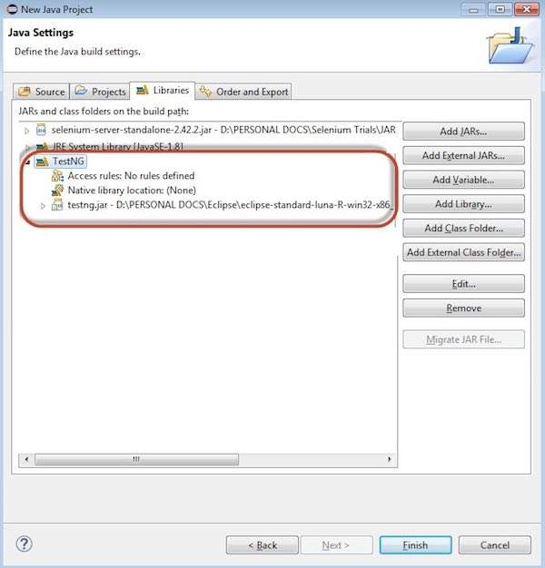

**Step 7**: Upon creating the project, the structure of the project would be as shown below.

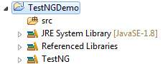

**Step 8**: Right-click on 'src' folder and select New >> Other.

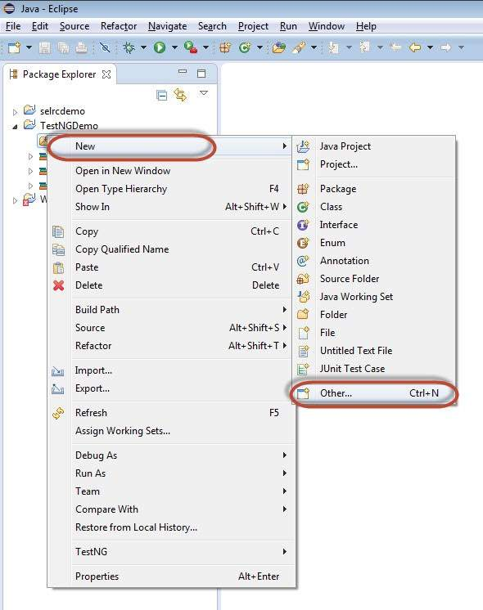

**Step 9**: Select 'TestNG' and click 'Next'.

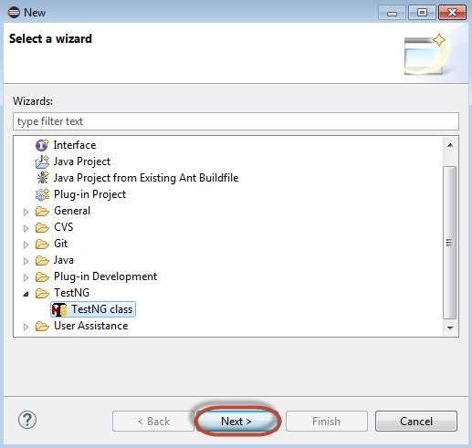

**Step 10**: Select the 'Source Folder' name and click 'Ok'.

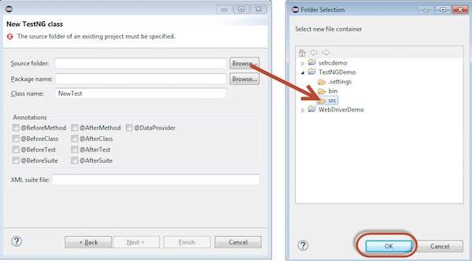

**Step 11**: Select the 'Package name', the 'class name', and click 'Finish'.

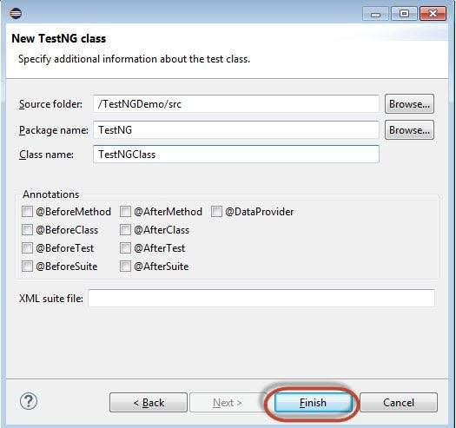

**Step 12**: The Package explorer and the created class would be displayed.

